

NAME: ABDUL REHMAN(BHATTI)

DEPARTMENT: BS CS(AI)

TO: SIR HAMZA

ASSIMENT NO 01

ASSIMENT NO #01:

QUESTION#01:

//NAME ABDUL REHMAN

#include<iostream>

using namespace std;

int main()

//QUESTION 01

{

int year;

int weight;

cout<<"\t\tFEDERAL BOARD OF REVENUE:\t\t"<<endl;

cout<<"MODEL YEAR=";

cin>>year;

cout<<"WEIGHT=";

cin>>weight;

if(year<=1970 && weight<2700)

{

cout<<"WEIGHT CLASS IS 1"<<endl;

cout<<"REG FEE IS RS 1650 "<<endl;

if(weight>=2700 && weight<=3800)

cout<<"WEIGHT CLASS IS 2"<<endl;

cout<<"REG FEE IS RS 2550 "<<endl;

if(weight>3800)

cout<<"WEIGHT CLASS IS 3"<<endl;

cout<<"REG FEE IS RS 4650 "<<endl;

}

else if(year>=1971 && year<=1979 && weight<2700)

{

cout<<"WEIGHT CLASS IS 4"<<endl;

cout<<"REG FEE IS RS 2700 ";

if ( weight>=2700 && weight<=3800)

cout<<"WEIGHT CLASS IS 5"<<endl;

cout<<"REG FEE IS RS 3050 "<<endl;

if(weight>3800)

cout<<"WEIGHT CLASS IS 6"<<endl;

cout<<"REG FEE IS RS 5250 ";

}

else if (year>=1980 && weight<3500)

{

cout<<"WEIGHT CLASS IS 7"<<endl;

cout<<"REG FEE IS RS 1950 "<<endl;

if(weight>=3500)

cout<<"WEIGHT CLASS IS 8"<<endl;

cout<<"REG FEE IS RS 5250 "<<endl;

}

else

cout<<"WRONG INPUT";

return 0;

}

QUESTION NO 02:

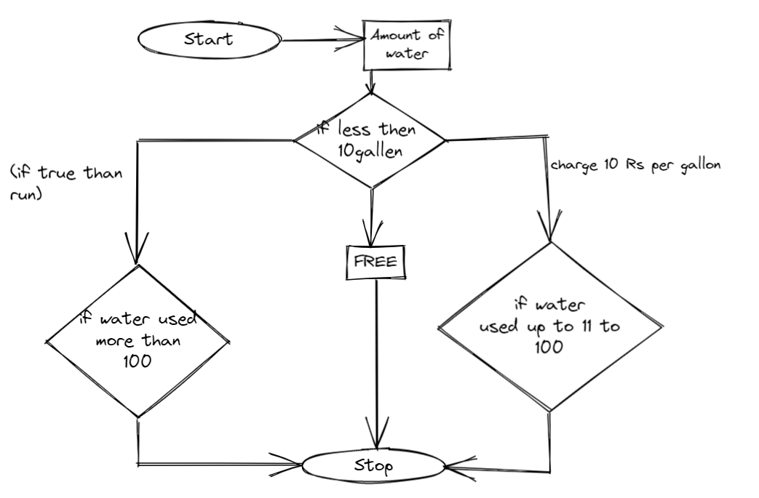

THE END😊